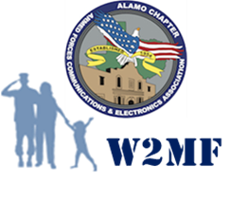

**Alamo Chapter**

**Wounded Warrior and Military Families**

**Endowment Fund**

The Alamo Chapter supports the Austin, San Antonio and South Texas communities, also known as Military City USA. Our chapter has had great success raising money to support our local STEM scholarships and grants program. Many service men and women come through San Antonio and has become a home for many Veterans, Military Families, and especially our Wounded heroes.

In 2014, the Alamo Chapter, partnering with the Military Warriors Support Foundation, hosted a special fundraising event at our annual Alamo ACE conference to support the donation of a mortgage-free home to a recipient from the Homes4Heros program. Working with MWSF, we identified an Army 255A Information Services Technician who was medically retired after 17 years of service and could benefit from a home. The event was so successful we used the remaining funds to create an Endowment Fund for continued support to local charities who do not have the financial engine that an AFCEA event can generate.

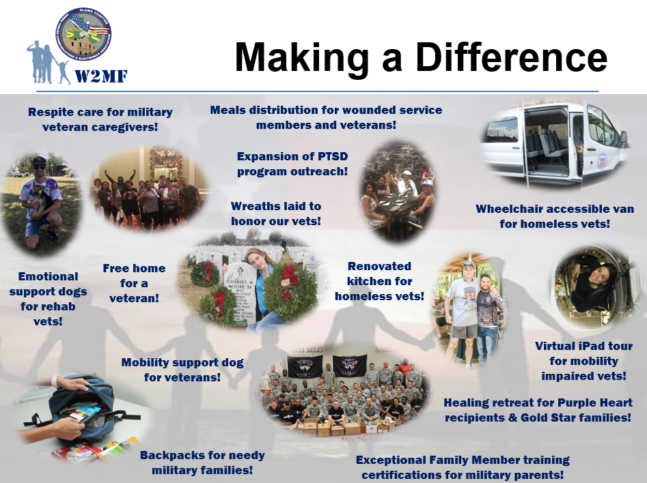The Endowments mission is to provide financial assistance for wounded warriors, military families and veterans through community-based programs and outreach assistance. The W2MF Committee facilitate Alamo AFCEA support to pre-vetted beneficiaries in need, while providing a framework for fund-raising and budget execution. We focus on frequently overlooked 501(c)(3) charities through which donations can have an immediate and profound impact on locally-focused programs. Preference given to those operating in South Texas.